



tABLE OF contents

Design history 3

Game concept 4

Target Audience 4

target platform 4

Platform 4

Minimal device 4

Recommended device 4

Game Flow Summary 5

Gameplay 6

Mechanics 7

Interactive Objects 7

Behaviors 8

Object relationships 9

Story and Game progression 10

Story and background 10

Game progression 10

Levels 11

Interface 12

AI 13

Cost 14

Project rules 16

Folder structure 16

File types 16

Technical choices 17

Rendering and view 17

Physics 17

Scene management 17

AI 17

Manager objects 17

Interface 18

Players 18

Data storage 18

Cutscenes 18

# Design history

|  |  |  |
| --- | --- | --- |
| Date |  | Changes |
| 12-03-18 |  | Initial design |
| 13-03-18 |  | Updated look of the document & added table of contents |
|  |  |  |
|  |  |  |
|  |  |  |
|  |  |  |
|  |  |  |

# Game concept

Stop the hunter is a game where you’re against different AI, they are the hunters and you are the activist. As the activist you are there to stop them from hunting the elephants. You shoot the hunter before it shoots the elephant. But don’t shoot the animals!

# Target Audience (clients point of view)

Because the WWF wanted a big audience for young and old we wanted to create something that appeals to every age group and can be played anywhere at any time. This is why we chose to create it on the mobile phone because it’s so accessible. People who have a newer phone, with touch screen can easily play the game at any moment without troubles. And with our cartoony carboard look it looks appealing but also more approachable for all the ages.

# target platform

## Platform

We are making this project to be able to run on a mobile phone ( Android / IOS )

## Minimal device

OS player requires iOS 7.0.

Android: OS 4.1; ARMv7 CPU with NEON support or Atom CPU; OpenGL ES 2.0 or later.

## Recommended device

A modern Iphone/Android with internet access and the latest phone update.

# Game Flow Summary

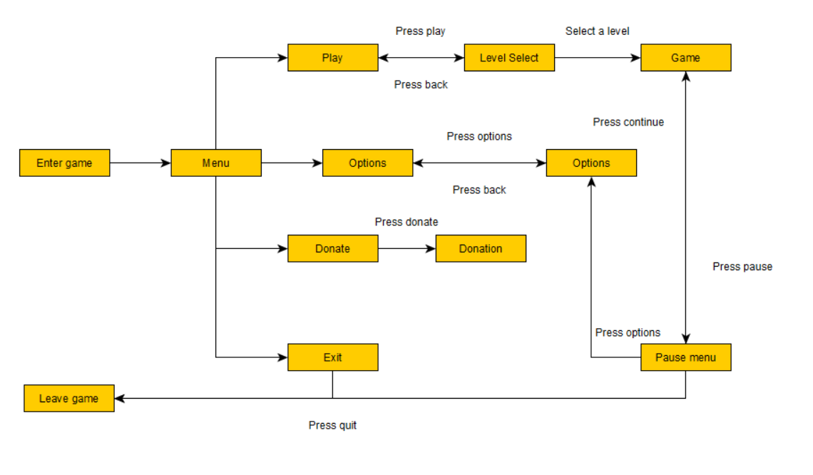

Every interaction happens with a tap of your finger(s) and you can view around you by rotating your phone around you. (this is only when the game is being played)

# Gameplay

By clicking the buttons with your finger(s) on the screen you move through the different menu’s in the game.

When you’re in the game screen you can tap on the screen and you shoot to the position where you placed your finger.

You can change directions by tapping on a different location on the screen, or rotate the phone around and see more of the screen.

You win when you save enough animals, and you lose when you don’t.

You don’t save enough animals when either you shoot the animals yourself or the hunters shoot them.

You can always go back to previous levels by going to the level select.

If at the end of the level you saved enough animals you’ll be directed to the donation screen, where will be asked if you want to donate. (with a button to the donation website)

If you lose the game you’ll get a screen with a informative text about the animal (and its endangerment) and you should try harder.

# Mechanics

## Interactive Objects

|  |  |  |  |  |
| --- | --- | --- | --- | --- |
| **Object** |  | **Does** |  | **How** |
| Play Button |  | Plays the game |  | Tapping the button |
| Options Button |  | Opens the option menu |  | Tapping the button |
| Donation Button |  | Opens the donation menu |  | Tapping the button |
| Exit Button |  | Exits the game |  | Tapping the button |
| Back Button |  | Goes back to the menu |  | Tapping the button |
| Timer |  | Keeps track of the time |  | By showing a counting down clock |
| Hunters |  | Can be shot to gain points / shoot the animals |  | Coded AI |
| Animals |  | Can be shot to lose points / are shot by hunters |  | Coded AI |

## Behaviors

|  |  |  |  |  |  |
| --- | --- | --- | --- | --- | --- |
| **Type** |  | **Description** |  | **How does it do it?** | **Expectable situations** |
| Button |  | When clicked something happens |  | When you click with your mouse something happens (what the name of the button says) | Plays the game, opens the option menu, opens the rules menu, exits the game, goes back to the previous screen, opens the pause menu |
| AI |  | Will pick a position on the map and shoots the animals |  | By using positions on the map it will pick a free spot and stand there to shoot the animals |  |
| Scoreboard |  | Shows the player the score of every other player |  | If you open op the score menu it will show how many points every player scored and how you get score | Shows the amount of animals you’ve saved at the end |
| Timer |  | Keeps track of the time you have left |  | Counts down from a timer |  |
| Player |  | Everything the player can do will be done here |  | It takes the input from the player, and uses it. |  |

## Object relationships

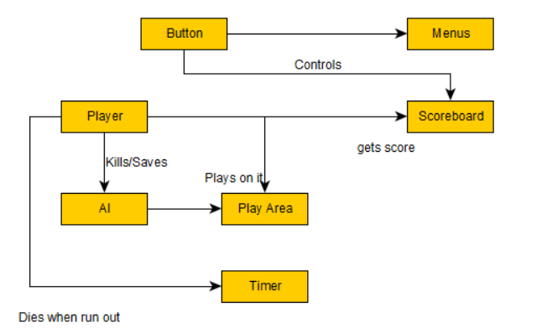

# Story and Game progression

## Story and background

Stop the hunter is a game where you’re against different AI, they are the hunters and you are the activist. As the activist you are there to stop them from hunting the animals. You shoot the hunter before it shoots the animals. But don’t shoot the animals!

## Game progression

As the game progresses through the levels, the AI gets more difficult. This by hiding more instead of standing in open sight and shooting faster. After every chapter you get an achievement that you saved that animal, this will also be when people will be informed about the endangered species that you just saved and will redirect you to the donation page.

# Levels

There are a total of 5 chapters. (with each their own animal that you have to save) Every chapter has 3 levels where you can collect stars. (for a time bonus/amount of animals you’ve saved/hunters stopped)

If you get 2 or more stars you’ll be able to progress to the next chapter. Each level has their own animal and land for that corresponding animal. The first chapter is the easiest, to make clear what the controls are and about time and score. After the levels progress the levels get harder, by adding more obstacles and making the AI harder each level.

The first chapter will be in the savannah, because it’s very open and you can easily spot hunters.

The second level will be in the water, there are some things to hide behind but it’s still very open.

The third chapter will be in the snow, because everything is white things are harder to spot.

The fourth level will be in the jungle, with many trees to obscure your vision.

The fifth chapter will be again in the snow but with a blizzard to obscure your sight.

# Interface

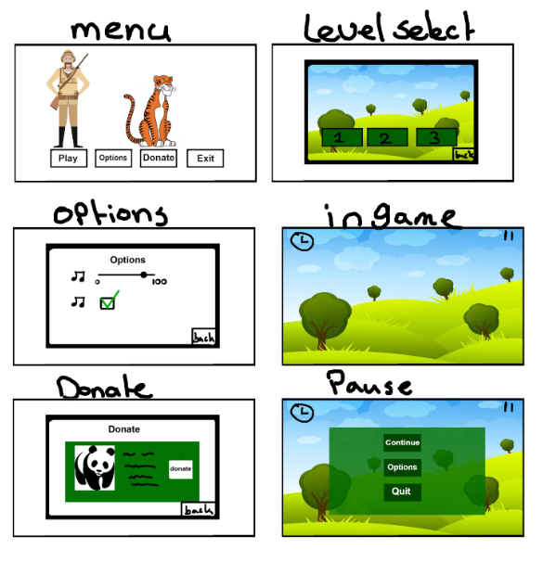

# AI

There are two AI systems in the game, one for the animals and one for the hunter.

The animals just pick a location and move around slowly and randomly make some noise or do an animation. If the player shoots the animal the player will lose score and the animal will die, making some type of scream and do a death animation.

The hunter will pick a spot on the map and shoot from that position. If you shoot him before he shoots you gain points and the hunter will drop dead. If you’re too late the hunter will shoot one of the animals and you’ll lose score.

After some period of time the hunters and animals will disappear and will respawn at a different location.

If at any point in time you miss a shot the hunters will find cover (and become harder to shoot) and the animals will run around for some time until they’ve calmed down.

# Cost

|  |  |  |  |  |  |  |  |  |
| --- | --- | --- | --- | --- | --- | --- | --- | --- |
| **Roles needed** |  | **Why?** |  | **How long needed** |  | **Cost per hour** |  | **Total cost** |
| Audio design |  | Every good game has music in it |  | 2 days |  | €45-, an hour |  | €720-, |
| Art (2) |  | We need to make it look pretty |  | 5 weeks |  | €40-, an hour |  | €8.000-, |
| Development (2) |  | We need someone to make the game |  | 12 weeks |  | €50-, an hour |  | €24.000-, |
| Play tester |  | We need some feedback from outside to make sure it’s fun to play |  | 4 days |  | €30-, an hour |  | €960-, |
| Project manager |  | We need someone to make plans and make sure everything goes as plan |  | 12 weeks |  | €60-, an hour |  | €28.800-, |
| Marketing manager |  | We need to let people know that the game is available |  | 6 weeks |  | €60-, an hour |  | €14.400-, |
|  |  |  |  |  |  |  |  | **Total : €76.880** |

People working on the project will mostly work 8 hours a day 5 days a week, we begin work at 8:30 am till 5:00 pm with half an hour break at 12:30. (breaks will not be charged)

|  |  |  |  |  |
| --- | --- | --- | --- | --- |
| **Accommodation** |  | **Usage** |  | **Cost** |
| Unity pro |  | This is where we will make the game in |  | €125 /month  €1.500 / year |
| Maya 2018 (optional) |  | We will make the models in here |  | €242 / month  €1.936 / year |
| Photoshop |  | We will make the design and textures in here |  | €24,19 / month  €290,17 / year |
|  |  |  |  |  |
|  |  |  |  | **Total: €319,19 / month**  **€ 3.726,17/ year** |

Since we’ll only work on this for 3 months the cost would be **€957,57**

Not including Maya 2018 will make it drop down to **€591,71**

All the cost together ( with paychecks & with Maya ) would be a total of **€77.837,57**

All the cost together ( with paychecks & without Maya ) would be a total of **€77.471,70**

# Project rules

## Folder structure

|  |  |  |
| --- | --- | --- |
| **Folder** |  | **What goes in** |
| Scripts |  | All scripts that are being made, and used go in here. Also in a sub folder with the usage |
| Assets |  | All art that comes in go in here, in a sub folder for location and usage |
| Textures |  | All textures go in here, in a sub folder for the object |
| Prefabs |  | All prefabs go in here |
| Animations |  | All animations go here, with a sub folder of usage |
| Music |  | All music go in here, with a subfolder for sounds ( like jumping ) and a folder for the type of music |
| Levels |  | Every level is in their own sub folder |

## File types

|  |  |  |
| --- | --- | --- |
| **File types** |  | **Purpose** |
| .wav |  | Sound/music |
| .fbx |  | So textures are already on it |
| .cs |  | All classes |
| .psd/png |  | .psd is for textures, .png is for alphas |

# Technical choices

## Rendering and view

Forward rendering path, because it’s the cheapest for mobile.

Gamma color space because it makes the mobile game look better.

The game will have a 2D side scrolling perspective view.

## Physics

it’s a 2D game, with no ragdolls, no physics because everything is done through code/animations.

## Scene management

We’ll have 2 scenes, the menu and the game. The load screen will be stacked on the game scene so it will load in the background.

## AI

We’ll use a behavior tree to check every possibility that the AI can make, and choose an appropriate option.

## Manager objects

We use managers, like an Audio manager that takes care of the audio.

|  |  |  |
| --- | --- | --- |
| **Manager** |  | **Responsibility** |
| Audio |  | Plays every sound/music |
| Level |  | Keeps track of the objects in the game |
| Score |  | Keeps track of the score in the game |

Everything that’s not in this list will be a scriptable object.

## Interface

We’ll use the basic Unity UI to make our GUI.

Everything can be clicked on it and the name interprets what it does. ( play goes to play mode, options opens an options screen etc. )

## Players

The game is a mobile game so, no LAN or split screen etc.

The player can play and interact with everything on screen with their fingers.

You aren’t able to change the controls since it’s a mobile game and the only input you have are your fingers.

## Data storage

All score will be saved into a small database with the levels that you’ve unlocked and scores.

There will only be a local highscore, so no competing against other payers

## Cutscenes

There will be no cutscenes in the game.